

Determinants of Early-Stage Startup Performance: Survey Results

# Thomas Eisenmann



**Working Paper 21-057**

Determinants of Early-Stage Startup Performance: Survey Results

## Thomas Eisenmann

Harvard Business School

**Working Paper 21-057**

Copyright © 2020 by Thomas Eisenmann.

Working papers are in draft form. This working paper is distributed for purposes of comment and discussion only. It may not be reproduced without permission of the copyright holder. Copies of working papers are available from the author.

Funding for this research was provided in part by Harvard Business School.

Determinants of Early-Stage Startup Performance: Survey Results

## Thomas Eisenmann

*Harvard Business School*

October 27, 2020

#### ABSTRACT

To explore determinants of new venture performance, the CEOs of 470 early-stage startups were surveyed regarding a broad range of factors related to their venture’s customer value proposition, product management, marketing, technology and operations, financial management, funding choices, team management, and founder attributes. Multivariate regression analysis shows that startups that employed lean startup management practices—in particular, an optimal rate of pivoting—had stronger seed equity valuation growth, as did new ventures that struck the right balance in recruiting for skill versus attitude and that professionalized human resource policies earlier. High levels of confidence in financial metrics—including estimates of unit economics, the ratio of customer lifetime value to customer acquisition cost, and total addressable market size— were also associated with strong growth in seed equity value.

Valuation outcomes were not related to several founder/CEO attributes, including age, educational background, personality traits, and motivations for becoming an entrepreneur. Likewise, choosing angels versus venture capital firms as lead seed round investors did not predict subsequent growth in equity valuation, nor did decisions about partnerships to provide technology, operational capacity, or marketing support.

The author is grateful to the Harvard Business School Division of Research and Faculty Development for financial support for this project, to Tom Nicholas, Bill Kerr, and Matthew Rhodes-Kropf for suggestions, and to HBS Research Associate Miltiadis Stefanidis for assistance with survey management and analysis.

Why do some entrepreneurs succeed while so many others fail? A large body of research addresses this question. Most of these studies closely examine the influence on startup performance of a specific set of factors of central interest within the authors’ discipline. For example, scholars of psychology may focus on founders’ personality traits; sociologists on founders’ network relationships; financial economists on the impact of capital market boom-bust cycles; scholars of technological innovation on shakeouts as dominant designs emerge; and so forth.

Empirical research that seeks to validate such theories typically measures the focal factors with care and precision. However, variables of central interest in other disciplines are often excluded in multivariate analysis; regression models typically include a fairly sparse set of control variables—say, company age, location, and industry sector. As a consequence, these models run the risk of omitted variable bias. If confounders were included, would parameter estimates for key predictors remain significant? Might other significant relationships be observed?

Randomized control trials, natural experiments, and the use of fixed effects and instrumental variables can reduce the risk of biased estimates for key predictors. However, without a more fully specified model that includes most potential covariates, such research designs will still leave a large fraction of variance unexplained. Meta-analysis affords an opportunity to include a broader range of variables. For example, drawing on 31 empirical studies, Song et al. (2008) use meta-analysis to explore the influence of a diverse set of factors on new venture performance. Surveys also can provide a more comprehensive view of factors

that might impact startup performance; they can be used to collect data that may not be available from published sources.

Many survey-based studies explore the impact of specific factors, but do so with a more robust set of control variables. For example: 1) Eggers & Song (2015), survey 253 Chinese founders to examine performance consequences when serial founders switch industries; 2) Wasserman (2017), uses panel data from 6,130 startups to explore relationships between founders’ governance choices and company valuation; 3) Eesley & Roberts (2012) use a sample of 2,067 MIT alumni entrepreneurs to examine the relative importance of innate ability and prior experience in predicting startup revenue; and 4) Keogh & Johnson (2019), use the Kaufmann Firm Survey of 4,298 new ventures to analyze the relationship between investor type and firm performance. Another stream of survey-based research asks venture capitalists which among a diverse set of attributes of startups and founding teams are most important in making investment decisions (e.g., Gompers et al., 2020; Gorman & Sahlman, 1989).

While surveys can provide data on a wide range of factors, they have well-known limitations. First, they are subject to attribution bias, that is, a focal actor’s propensity to blame bad outcomes on other parties or uncontrollable events. This bias can be tempered by surveying multiple actors—say, all of a startup’s co-founders and lead investors—but that may reduce survey response rates. Second, survey responses are vulnerable to measurement error due to faulty recollections and ego-defensive misrepresentation. Third, there is an inherent tradeoff between adding more questions to a survey—in order to measure factors with greater precision or to explore additional factors—and boosting survey response rates.

Notwithstanding these potential limitations, this study employs a survey of 470 founders/CEOs to explore a broad range of factors that might influence the performance of U.S.- based early-stage startups. Respondents raised a seed round of $500,000 to $3 million between January 1, 2015 and April 30, 2018. They were asked how their estimate of the value of their

seed round equity as of year-end 2019 compared to its original value—or, in the case of firms that had been acquired or shut down, how the value of any proceeds received by seed round investors compared to the value of their original investment.

Based on bivariate and multivariate analyses, several sets of related factors had strong relationships with valuation outcomes. Performance was better for startups whose teams followed lean startup management practices; these teams conducted more upfront customer research, ran minimum viable product tests, and were more likely to pivot with optimal frequency. This finding is noteworthy, since only a single empirical paper (Camuffo et al., 2019) has previously assessed the performance consequences of lean startup practices.

Close attention to financial metrics was also associated with better valuation outcomes.

Performance was stronger when founders had greater confidence in their estimates of total addressable market size, unit economics, and the ratio of customer lifetime value to customer acquisition cost (LTV/CAC). Finally, several factors related to team management were positively related to valuation outcomes. Following a structured, disciplined approach to human resource management, striking the right balance in recruiting for skills vs. attitude, and having clarity on top team members’ responsibilities were among the predictors related to better performance.

Other sets of factors had weaker than expected relationships with valuation outcomes.

The extent of a startup’s reliance on strategic partnerships—to provide technology, support operations, or acquire customers—did not predict outcomes. Likewise, investor type—angel versus venture capital firm—was not a statistically significant predictor of performance, nor was status as an elite investor (defined as a top 100 ranking, based on total number of seed round investments made in the 2,822 early-stage startups invited to participate in the survey). Finally,

several attributes of founder/CEOs were not significant predictors of valuation outcomes, including holding an MBA or any degree from one of the world’s top fifty universities; prior experience in functional roles (e.g., engineering, marketing, etc.); prior relationships between co- founders; self-assessed personality traits; and personal motivations for becoming an entrepreneur. The weak predictive power of founder attributes in this study’s regression analysis calls into question the conventional wisdom espoused by many venture capitalists, who hold in that deciding whether to invest in a startup, the ability of its “jockey” (i.e., founder) is more important than that of the “horse” (i.e., the attractiveness of the startup’s opportunity).

The balance of this paper first presents a brief review of some past research on factors that may influence startup performance. Next, I discuss my research methods in three sections that describe my survey sample, measure of startup performance, and analytical approach.

Departing from convention for empirical papers, I dispense with a section that presents formal hypotheses to be tested. Given the large number of factors that I explore, explaining how and why each factor might influence startup performance and citing relevant research would result in an excessively long section. Instead, in reviewing findings, I briefly state my initial expectations regarding each factor’s relationship with performance, and then discuss whether these expectations were borne out by bivariate and multivariate analyses. The paper concludes with section on limitations of the research and a discussion of implications for future research and for practitioners.

# PAST RESEARCH

Many different factors can influence startup performance. A large fraction of past research on entrepreneurship examines relationships between these factors and new venture

performance, so a thorough review here of relevant literature would be unwieldly. Instead, I will cite just a few studies in each of four categories that respectively explore the relationship of startup performance to attributes of: 1) founders; 2) investors; 3) product markets; and 4) management processes.

**Founders.** Past research on founders’ influence on startup performance addresses founders’ backgrounds, founders’ personality traits, and founding team composition.

Background attributes shown to be positively associated with performance include founders’ age (Azoulay et al., 2019); status as a previously successful serial entrepreneur (Gompers et al., 2010); and prior industry sector experience (Eesley & Roberts, 2012; Chatterji, 2009; Agarwal et al., 2004).

In a literature review, Sorensen & Chang (2006) conclude that empirical evidence for the impact of several personality traits—including need for achievement, internal locus of control, risk taking, and social deviance—is at best mixed. Baron & Markman (2003) show that greater social competence increases entrepreneurs’ incomes. Meta-analysis presented in Zhao et al. (2010) shows that four of the Big Five stable personality traits—conscientiousness, openness to experience, extraversion, and emotional stability—are positively associated with new venture performance; the fifth, agreeableness, is not. Several studies posit that founder overconfidence can boost failure odds (e.g., Navis & Ozbek, 2016; Bernardo & Welch, 2001); Camerer & Lovallo (1999) and Artinger & Powell (2016) present experimental evidence supporting this conjecture.

With respect to founding teams, Klotz et al. (2014) survey literature on new venture teams and present a framework linking team composition to venture outcomes. In this framework, the distinction between affective and constructive conflict—elaborated in Ensley et

al. (2002)—serves as an important mediator. Addressing governance choices, Wasserman (2017) shows that founders’ ongoing control of the CEO position and the board are negatively correlated with higher valuation.

**Investors.** Entrepreneurial finance research addresses three questions about startup performance. First, do choices regarding investor type—for example, angel investors vs. venture capital firms—influence success odds? Hellman & Puri (2000) show that more innovative startups prefer to raise capital from VC firms than other sources, and that VC-backed startups launch products faster than rivals not funded by VC firms. Vanacker et al. (2013) compare the value-added of VC firms and angels and their respective impact on startup performance. VC value-added takes the form of quality signaling along with useful advice and network connections (Gompers et al., 2020; Gorman & Sahlman, 1989).

Second, does backing from VC firms with strong reputations boost startup success odds? Hsu (2004) does not directly address this question but shows that entrepreneurs are three times more likely to accept financing offers from high reputation VCs who, on average, pay 10-14% less for their equity than other investors.

Finally, how do boom-bust cycles in capital markets influence startup performance?

Nanda & Rhodes-Kropf (2013) find that startups funded during boom periods are more likely to both fail and to be extremely successful, compared to counterparts funded during periods of normal or reduced investment activity.

**Product Markets.** Strategic management scholars have different explanations—which are not mutually exclusive—for excess entry by entrepreneurs into new markets. Hogarth & Karelaia (2012) hold that excess entry is a natural consequence of fallible judgment, which in turn is due to entrepreneurs’ bounded rationality and high uncertainty about new markets. This

combination yields an imperfect correlation between aspiring entrepreneurs’ projections of their payoff from entry and the actual payoffs they would realize, if they entered. If entry hinges on

the aspirant projecting a payoff that surpasses some threshold level, then some aspirants will overestimate their payoff, enter, and fail; others who could survive will underestimate their payoff and avoid entry. The pool of entrants will be thus comprised of some survivors that truly had promising prospects and others who were destined for failure due to overestimation.

This explanation for excess entry requires no overconfidence on the part of entrepreneurs; excess entry occurs if the mean of the distribution of projected payoffs assessed by individual aspiring entrepreneurs matches the actual payoff they would receive upon entry. However, excess entry is amplified if entrepreneurs are overconfident, and is likewise exacerbated in smaller markets and with higher levels of uncertainty. Artinger & Powell (2016) show that 40% of excess entry in experimental simulations was due to subjects’ overconfidence; the remainder was a consequence of fallible judgment—random projection errors in the face of uncertainty— that could occur in the absence of overconfidence.

Markets with winner-take-all structural attributes—in particular, strong network effects— provide another explanation for high rates of startup mortality in some new markets (e.g., Noe & Parker, 2005; Eisenmann, 2006; Schilling, 2017). Likewise, theories that hold that new technologies converge over time toward a dominant design (e.g., Suarez et al., 2015; Klepper, 1997) predict a shakeout among early entrants.

**Management Processes.** Early-stage entrepreneurs who follow lean startup management practices (Ries, 2011; Blank, 2013) undertake a thorough round of research on the needs of potential customers before they commence engineering work, and then test hypotheses about their proposed solution through a series of “minimum viable product” tests, which aim to gain

“validated learning” while avoiding wasted effort. Academic literature on lean startup practices is just starting to appear. For example, Felin et al. (2020) express skepticism regarding the efficacy of these practices; see Bocken & Snihur (2020) for a response. Contigiani & Levinthal (2019) explain how lean startup ideas relate to past organizational theories and propose a research agenda for scholars. To date, however—as far as I know—only a single empirical study has examined the performance consequences of employing lean startup management practices.

Camuffo et al. (2019) conducted a one-year randomized control trial of 116 early-stage Italian startups, and found that entrepreneurs who followed a rigorous approach to formulating and testing business model hypothesis fared better than the control group.

# SAMPLE

In selecting my survey sample, I targeted startups that: 1) were at a comparably early stage in their development; 2) were perceived by external parties at the outset of that stage to have promising prospects; and 3) had broadly similar performance drivers. Using PitchBook data, the survey targeted all U.S-based startups founded in 2013 or later that raised a first major funding round of $500,000 to $3 million between January 1, 2015, and April 30, 2018 (and no more than $250,000 prior to this first major round).

Raising a first major funding round implied that the startups were still at an early stage of development but had made enough progress to attract significant investment. Being founded after 2012 excluded ventures that had been bootstrapped over a longer time frame before raising external capital. Such ventures might have had seasoned teams and more mature products—and therefore, different performance drivers than younger startups. Focusing only on startups

headquartered in the United States yielded a sample that faced similar macroeconomic and capital market conditions.

Requiring a first round of $500,000 to $3 million omitted, at the low end, ventures that might have been deemed to be underdeveloped or to have marginal prospects. At the high end, the funding range excluded ventures that were highly capital intensive; such firms may have had different performance drivers. The sample startups were concentrated in three sectors: information technology, business services, and consumer products and services. The sample excluded biotech, energy, and material science–based startups due to their distinctive performance drivers, relative to the other sample firms.

Selecting ventures that raised their first round between January 1, 2015 to April 30, 2018 served three objectives. First, this forty-month window meant that the startups faced broadly similar macroeconomic and capital market conditions as they developed, reducing the impact of time-varying exogenous factors. Second, by limiting the sample to ventures that had raised their first round within the past five years, I hoped to avoid gaps in founders’ recollections, which would be more problematic with older startups. Finally, since the survey was conducted during the spring of 2020, raising a first round before April 30, 2018 allowed all of the sample companies to develop for at least two years after closing that round, yielding a spread in performance outcomes.

These screening criteria yielded 3,263 candidates. For 2,822 of them, PitchBook had contact information for the individual who was CEO when the startup raised its first major round. I reached out to all of them, and 470 CEOs completed the survey: a 17% response rate.

Company founders accounted for 97% of respondents; the balance were non-founder CEOs. Of the 470 respondents, 89% led startups that were still operating and independent when

they completed the survey, 8% had sold their ventures, and 3% had shut down. This compares to 8% sold and 7% shut down among the 2,822 startups invited to participate. Consequently, shutdowns are underrepresented in the sample.

I ran a binary logistic regression to determine whether survey respondents differed from the full set of invitees in other ways. Besides survey respondents being less likely to have shut down, statistically significant predictors in this model (p < .05) included founding date (e.g., 14% of respondents were founded in 2013 or 2014, compared to 18% of invitees); amount of seed round capital raised (mean of $1.63 million for respondents, compared to $1.56 million for invitees); having headquarters in California (32% for respondents, compared to 41% for invitees); and having a business-to-consumer (B2C) offering (19% for respondents, compared to 21% for invitees).

Not surprisingly, shutting down was positively correlated with startup age: among all invitees, 9.7% of firms founded in 2013 or 2014 had shut down, compared to 5.8% of firms founded in 2015 or later. It seems possible that lower survey response rates for both older startups and shut down startups may have been related to out-of-date contact information for founder/CEOs in PitchBook.

Further regression analysis showed that survey respondents that had shut down did not differ in any statistically significant way from non-respondents that had shut down, with respect to attributes observable through their Pitchbook profiles: founding date, amount of seed capital raised, headquarters location, and industry sector. Because the rate of underrepresentation of shutdowns was roughly constant for all of these attributes, when predicting valuation outcomes, the survey’s underrepresentation of shutdowns should not bias the attributes’ parameter estimates.

# PERFORMANCE MEASURE

Past empirical papers employ several different measures of startup performance, including venture survival (e.g., Keogh & Johnson, 2019), growth in revenue or employees (e.g., Azoulay et al., 2019; Eggers & Song, 2015; Eesley & Roberts, 2012), equity valuation (e.g., Wasserman, 2017), going public (e.g., Gompers et al., 2010), and return on invested capital (e.g., Kerr et al., 2014).

My measure of performance—a variant of return on invested capital—is based on the change in the value of equity raised in a startup’s first major funding round, which usually was labeled a seed round: Did the value of this equity increase, stay roughly the same, or decrease— at the extreme, going to zero? Specifically, the CEOs of startups still operating were asked, *As of December 31, 2019, before news of the coronavirus pandemic became widespread, how much would someone have paid for your startup’s first round equity/convertible notes?* The multiple- choice options were: 1) > 150% of the amount originally invested; 2) 50% to 150%; or 3) < 50%. Respondents were also told, *We know that first round equity and convertible notes cannot normally be sold—but imagine that they could. How much might an experienced, well-diversified investor have paid your largest first round investor to take over their position on December 31, 2019? Assume that equity or notes would be transferred with terms intact (e.g., liquidation preferences, discounts, caps).*

Respondents whose startups were sold or shut down were asked the same question about the value (if any) of proceeds distributed to early investors. Specifically: Compared to the amount these investors originally invested, were any proceeds they received worth > 150%; 50% to 150%; or < 50%?

In the analysis below, the outcomes are labeled high valuation (> 150%), middle valuation (50% to 150%), and low valuation (< 50%). Of those surveyed, 63% reported a high valuation, including 66% of the 420 firms still operating and independent, 47% of the 36 acquired startups, and one of the 14 startups that had shut down. Middle valuations—27% of outcomes—included 27% of firms still operating and independent, 28% of acquired startups, and 29% of startups that had shut down. Low valuations accounted for 10% of overall responses, consisting of 7% of firms still operating and independent, 25% of acquired ventures, and 64% of the startups that had shut down.

To explore factors that contributed to startup failure, I decided to compare low and high valuation outcomes, rather than surveying startups that had actually shut down and then comparing them to successful going concerns—say, those that completed an IPO or were acquired with proceeds yielding a capital gain for investors. I did this for two reasons. First, to obtain a sufficient number of shutdowns and exits for statistical analysis, I would have had to sample startups further into the past. The expanded time frame would have posed problems with the reliability of respondents’ recollections.

Second, my sampling approach conforms to the following definition of startup failure: *A venture has failed if early investors did not—or never will—get back more money than they put in.* When exit proceeds are less than total capital raised, liquidation preferences held by investors in later rounds typically ensure that they get their money back before investors in earlier rounds receive any proceeds. Thus, early investors may receive less than they invested or nothing at all. Outcomes are commensurately worse for common shareholders, including founders.

Failure along these lines seems like a distinct possibility for a startup that, while still operating today, has a current equity valuation that’s less than one-half of the original value of

the seed capital it raised. Of course, some of these low valuation ventures might be turned around and ultimately succeed. And, many high valuation ventures in the sample will ultimately fail.

However, since those outcomes cannot be reliably predicted, my goal was to compare groups of early-stage startups that, based on the definition above, seemed to be *trending toward failure* with those *trending toward success.*

I used a categorical measure of valuation rather than a continuous measure for two reasons. First, with a continuous measure, founders would have been forced to provide a precise estimate their current valuation. Unless they had recently raised a new round, this would be an error-prone task for early-stage startups that lack a long operating history. Assessing valuation within broad ranges seemed less subject to error. Second, I was concerned that asking founders for a specific valuation might deter some founders from participating in the survey, out of fear

that the estimate could be leaked (even though I had promised confidentiality) and could compromise the founder’s negotiating position with potential investors.

Concerns about confidentiality—or ego-defensiveness—might also have motivated some founders to inflate valuation estimates.1 Nevertheless, even if such inflation happened, I believe that this study’s findings would still hold. To explain: If some respondents exaggerated their

performance, then the high valuation responses I observed would be a blend of data from startups that truly do have a high valuation and those that inflated their valuation. If a factor genuinely

1 I considered using PitchBook’s valuation data but rejected this option because valuation data for the sample firms were often not available or not sufficiently current to provide a reliable measure of performance as of year-end 2019. Specifically, PitchBook does not provide any valuation data for 28% of the firms reported by survey respondents to still be operating and independent. Reasonably current valuation data—based on a financing transaction completed within 12 months of the survey response—was available for only 16% of the operating and independent firms.

Likewise, the value of acquisition proceeds is available for only 18% of acquired firms, for the balance, proceeds are not reported. Finally, for 25% of firms reported by survey respondents either to have shut down or to have been acquired, PitchBook indicates that the firms are still operating and independent—in most instances, because their PitchBook entry has not been updated for more than a year.

has a strong, positive impact on a startup’s valuation, this kind of blending would reduce the reported impact of that factor. Consequently, if bivariate or multivariate analysis shows that a factor is a strong predictor, we can presume that its impact would be even stronger if any inflated valuations could be corrected.

# ANALYTICAL APPROACH

The survey posed forty questions about factors that might influence startup failure and success odds; these factors related to the venture’s value proposition, product management, marketing, technology and operations, financial management, funding choices, team management, and founder/CEO attributes (see Appendix for survey questions). The requested time frame for assessing the factors varied, but the general aim was to reflect the startup’s situation during the first two years after raising its seed round.

For multivariate analysis, I employed multinomial logistic regression because the data did not satisfy ordinal regression’s requirement for proportional odds.2 However, results for ordinal regression (not reported here) are similar to those for the multinomial model.

As a first step, I conducted bivariate analysis of potential predictors’ relationships with valuation outcomes. To conserve degrees of freedom, I excluded some potential predictors from the multivariate regression model if: 1) I did not have strongly held hypotheses about their relationship with valuation outcomes; and 2) bivariate analysis did not reveal a statistically significant relationship with valuation outcomes (p < .05). For example, I asked respondents about their motivations for pursuing an entrepreneurial career. I did not have a prior view as to

2 That is, the effect of predictors on the odds of moving from low to medium valuation outcomes was not the same as their effect on the odds of moving from medium to high outcomes. Based on a test of parallel lines, the null hypothesis of constant slope coefficients across outcome categories was rejected; p = .049.

which motivations (e.g., desire for independence; desire to build personal wealth) might be associated with venture performance, and none were, so I omitted those variables from the regression model.

In a few cases, bivariate analysis indicated that among several related attributes, only one exhibited a strong relationship with valuation outcomes. Examples included California among a set of startup hubs and information technology among a set of industry sectors. Rather than include a full system of indicator variables encompassing all possible responses, to conserve degrees of freedom, the regression model includes only indicators shown through bivariate analysis to be strongly associated with valuation outcomes.

I reviewed correlations between independent variables to check for potential problems with collinearity. Three sets of related variables had correlations greater than .3, but excluding variables from each set had no material impact on the sign or significance of parameter estimates for the sets’ remaining variables.3 Consequently, I included all related variables in the regression model, to avoid omitted variable bias and provide a more complete view of factors that might influence early-stage startup performance.

# RESULTS

The regression model exhibits good fit with N = 470; chi square difference for likelihood ratio test of model fit = 206.5, with 96 degrees of freedom and significance level = .000; and Cox & Snell pseudo R-square = .356. The model classifies 69% of observations in the correct

3 The sets included: 1) category maturity and number of late-stage startup rivals (r = .32); 2) confidence in estimates of LTV/CAC and unit economics (r = .54), along with confidence in long-term profit potential, which was correlated with confidence in estimates of TAM (r = .31), unit economics (r = .30), and LTV/CAC (r =.37); and 3) frequency of conflict among senior managers and degree to which such conflict was “cool” vs. “hot” (r = .63).

valuation category.4 By comparison, randomly assigning observations to outcome categories to match each category’s actual proportion in the sample classifies 47% of observations correctly.

Table 1 briefly describes the independent variables and shows each variable’s sample means for respondents with low, medium, and high valuations. Table 2 presents regression model results. Coefficients in multinomial logistic regression models can be difficult to interpret; they reflect the change in the log of relative odds (i.e., the odds of observing the focal outcome relative to the odds of observing the reference outcome) due to a one unit increase in the predictor, holding other independent variables constant. Specifically, by inspecting coefficients’ signs, it is not always straightforward to anticipate whether increasing the value of an independent variable will increase or decrease the predicted probability of the focal outcome. For this reason, Table 3 presents predicted probabilities for the low valuation outcome as each independent variable is ranged from its lowest to highest possible value, while holding all other independent variables constant at their respective sample mean.

In discussing results, I focus principally on whether the changes in predicted probabilities presented in Table 3 are consistent with hypotheses about each predictor’s relationship with valuation outcomes. Below, I’ll discuss these changes in predicted probabilities not only for variables that are statistically significant in the regression model (p < .05), but also for select independent variables of theoretical interest for which we cannot reject the null hypothesis. I also note when independent variables have a statistically significant relationship with valuation

4 Observations were assigned to outcome categories based on comparison of predicted probabilities for the outcomes, with the total number assigned to each category constrained to match the category’s actual proportion in the sample. With unconstrained assignment based simply on the highest predicted probability, 67% of observations were classified correctly. However, with unconstrained assignment, only 36 and 80 observations are classified in the low and medium valuation categories, respectively, compared to 48 and 127 observations in those categories in the actual sample.

outcomes in bivariate analysis (p < .05) but not in the regression model, since it is possible that a true effect is being masked by a lack of statistical power in the regression model.5

### Control Variables

A startup’s founding date, headquarters location, and industry sector were included in the model as control variables; I did not have strongly held hypotheses about their respective relationships with valuation outcomes.

**Founding Date.** It seemed possible that startups with more recent founding dates might be concentrated in the middle valuation category (i.e., 50% to 150% change versus seed round), since they had less time to succeed or fail. Contrary to this expectation, the predicted probability of being in the middle category declined from 27% to 16% as founding dates were ranged from 2013 to 2018. However, this relationship was not statistically significant.

**Location.** It likewise seemed possible that early-stage startups headquartered in the startup hubs in California, New York and Massachusetts might fare better than counterparts elsewhere, by virtue of having superior access to funding and talent. Alternatively, advantageous access to resources might have attracted more entrants and boosted failure rates in these locations.

Bivariate analysis indicated that among the startup hubs, being located in California had the strongest relationship with valuation outcomes. Compared to counterparts headquartered elsewhere, startups located in California, accounting for 32% of the sample, were somewhat more likely to have both low valuations (13% for California vs. 9% elsewhere) and high

5 There is no straightforward test for statistical power with multinomial logistic regression.

valuations (65% vs. 62%). While these differences are not large or statistically significant in the regression model, the pattern suggests that entrepreneurs in California—perhaps in the sway of Silicon Valley’s cultural norms—might be more inclined to “swing for the fences,” managing in ways that boost both failure and success odds.

**Industry Sector.** I explored the relationship between a startup’s industry sector and valuation outcomes, since it seemed possible that mortality rates might be higher in some sectors than others. Bivariate analysis of five industry sector categories (using PitchBook’s classification scheme) indicated that information technology had the strongest relationship with valuation outcomes. Specifically, information technology startups, representing 53% of the sample, were less likely to have low valuations and more likely to have high valuations (8% low and 66% high), compared to counterparts offering consumer products and services (17% low and 58% high; representing 19% of the sample) or business services (10% low and 65% high; representing 13% of sample). The regression model’s predicted probability of low valuation for startups offering information technology was 8%, compared to 12% for startups in other sectors. With p

= .054 for the low valuation outcome, the information technology indicator narrowly missed the 5% threshold used here for statistical significance.

### Customer Value Proposition

Startups with a strong customer value proposition relative to that of competitors were expected to fare better, as were startups that took steps to iteratively improve their value proposition, by employing lean startup management practices.

**Category Maturity.** I did not have strong expectations about the relationship between the maturity of a startup’s product category and valuation outcomes. On the one hand, early- stage startups operating in more mature categories might face strong competition from well-

entrenched rivals. On the other hand, a mature category might harbor more niches for a startup’s differentiated offering, and incumbents in the category might be slow to respond to entrants due to big companies’ inertial tendencies.

In the regression model, category maturity was not a statistically significant predictor of valuation outcomes. The model’s predicted probability of low valuation increased modestly from 9% to 12% as category maturity was ranged from its youngest value (< 2 years) to its oldest value (10+ years). Consistent with this, 53% of high valuation startups reported that their product category had existed for less than two years, compared to 44% for low valuation startups.

**Number of Rivals.** Startups that faced more rivals were expected to struggle. Competing with large numbers of late-stage startups could be especially troublesome, because they would have superior resources and established customer relationships. Big, mature companies would also have advantages of incumbency, but a nimble early-stage startup might be able to out- maneuver a slow-moving big corporation. Finally, fellow early-stage startups and small businesses of any age (e.g., “mom and pops”) were presumed to pose less of a competitive threat due to resource limitations.

Bivariate analysis indicated that among the four competitor categories mentioned above, the number of late-stage startups (defined as being 5 to 10 years old) had the strongest relationship with valuation outcomes. In the regression model, the number of late-stage startups was a significant predictor, with the probability of low valuation increasing from 7% to 16% as the number of late stage rivals was ranged from zero to its highest value, four or more.

**Product Performance.** Respondents who said that their startup’s product had a big edge over the product of their most important rival, in terms of having unique features and performance benefits, were expected to fare better than startups whose product performance lagged. Consistent with this expectation, the predicted probability of low valuation decreased from 18% to 9% as a startup’s relative product performance ranged from “far worse” to “far better.” Surprisingly, however, product performance was not a statistically significant predictor in the regression model.

**Early Adopter and Mainstream Customer Needs.** When early-stage startups confront large differences between the needs of early adopters and mainstream customers, their teams must make difficult product design decisions. For example, should they initially tailor their product to the needs of early adopters, and then modify it over time to meet the different needs of mainstream customers? Doing so might muddle the product’s positioning. To avoid this, when the mainstream market is ripe, should they instead launch a separate product tailored to its requirements?

Beyond such design choices, startups run the risk of not recognizing differences between the needs of early adopters and mainstream customers until after they have made major resource commitments. Falling victim to a false positive signal about demand, they may expand aggressively to serve early adopters, then be surprised to find that they’ve saturated that market. Upon pivoting to target mainstream customers, they may lack the capital to fund the necessary reconfiguration of resources. For these reasons, I expected failure odds to be greater for startups that confronted big differences between the needs of early adopters and mainstream customers.

Consistent with this expectation, the predicted probability of low valuation increased from 7% to 17% as customer needs for early adopters and mainstream customers ranged from

“nearly identical” to “very different.” While this relationship between the difference in customer needs and valuation outcomes was statistically significant in bivariate analysis, the difference in customer needs was not a significant predictor in the regression model.

**Lean Startup Practices.** Early-stage startups that employed lean startup practices were expected to develop more compelling customer value propositions and thereby improve their success odds. These practices include conducting extensive customer discovery research before launching products and pivoting in response to customer feedback gleaned through minimum viable product (MVP) tests. However, it also seemed possible that startups following lean startup practices—and embracing the lean startup precept “fail fast”—would be more likely to shut down within the study’s time frame after getting decisively negative results from MVP tests.

Survey responses were broadly consistent with the expectation that following lean startup practices would improve performance. 38% of low valuation startups completed at least six months of customer research before launching their products, compared to 53% of high valuation counterparts. Likewise, 29% of low valuation startups completed one or more rigorous MVP

tests, compared to 47% of high valuation counterparts When they launched their products, 15% of respondents who led low valuation startups reported having very deep understanding of customer needs, compared to 29% of counterparts in high valuation startups. All of these variables had a statistically significant relationships with valuation outcomes in bivariate analyses. However, none were significant predictors in the regression model.

Pivoting with the wrong frequency was also correlated with low valuation outcomes. Not pivoting often enough increased the predicted probability of a low valuation to a statistically significant 22%, compared to 6% for optimal frequency. Likewise, pivoting too often increased

the predicted probability of a low valuation to 19%, although this indicator—while statistically significant in bivariate analysis—was not a significant predictor in the regression model.

### Technology and Operations

**Structured Engineering Management.** Successful startups were expected to take a more structured approach to managing the engineering function—for example, conducting sprints, relying on automated testing; developing feature roadmaps, etc.—because a lack of structure could contribute to product development delays and quality problems. While not statistically significant, the predicted probability of low valuation decreased from 20% to 11% as the level of structure in engineering management ranged from “almost none” to “very high.”

**Proprietary IP.** Startups reporting that proprietary intellectual property was very important to their product’s performance were also expected to fare better, since proprietary IP could confer sustainable competitive advantage. While not statistically significant, the predicted probability of low valuation decreased from 13% to 6% as responses regarding reliance on proprietary IP ranged from “not at all important” to “extremely important.”

**Outsourcing.** Startups that reported relying too much on third-party providers for technology or operational capability (e.g., warehouses, call centers) were expected to struggle due to partners’ lack of responsiveness and poor alignment with strategic priorities. Likewise, startups that reported relying too little on outsourcing were expected have high fixed costs, increasing their exposure to revenue shortfalls and thus their failure odds. However, too much or too little outsourcing had little impact on the predicted probability of low valuation, and these indicators were not statistically significant predictors in the regression model.

### Marketing

**Reliance on Channel Partners.** Startups that relied heavily on channel partners to acquire customers were deemed to be at greater risk due to partners’ potential lack of responsiveness and alignment with strategic priorities. However, the 39% share of low valuation startups relying on marketing partners was similar to the 35% share for high valuation startups. Furthermore, as with reliance on third-party providers for technology or operational capability, heavy reliance on marketing partnerships had little impact on the predicted probability of low valuation and was a not statistically significant predictor.

**Spending on Demand Generation.** Startups were also expected to fare more poorly if they reported either: 1) overspending on demand generation; or 2) underspending, despite having had enough capital to boost marketing outlays. Consistent with the first hypothesis, overspending on demand generation—a statistically significant variable—increased the predicted probability of low valuation to 19%, compared to 8% for startups spending at optimal levels. However, underspending on demand generation had little impact the predicted probability of low valuation, and was not a statistically significant predictor in the regression model.

### Profit Formula

Given resource scarcity in many early-stage startups, close attention to financial metrics was expected to be a key factor for success. Targeting a small market can limit a startup’s growth, so understanding total addressable market (TAM) is crucial. Also, monitoring the ratio of customer lifetime value (LTV) to customer acquisition cost (CAC) is important to ensure that

marketing investments yield a positive return. In turn, projecting LTV requires an understanding of a startup’s unit economics. Furthermore, entrepreneurs leading early-stage startups must have reliable cash flow projections so they can pace fundraising efforts properly. Likewise, they must manage their burn rate carefully, given financing risk. Finally, investors will expect founders to be able to explain how their startup will earn profits over the long term.

**Financial Metrics.** Regression model results support these conjectures: confidence in TAM estimates, LTV/CAC estimates, and long-term profit potential were all statistically significant predictors in the regression model. As with other relationships reported here, we cannot infer causation. It seems possible that developing more accurate measures and using them to guide management decisions improved startups’ success odds. Alternatively, it is plausible that the volatility and pivots associated with startups’ struggles made it more difficult to assess

the measures accurately.

Moving from low to high confidence in TAM estimates reduced the regression model’s predicted probability of low valuation from 15% to 10%. Confidence in LTV/CAC estimates was a strong predictor of valuation performance. Moving from low to high confidence regarding estimates of LTV/CAC ratios reduced the predicted probability of low valuation from 18% to just 2%. Likewise, having a low level of confidence in a startup’s long-term path to profitability resulted in a 36% predicted probability of low valuation, compared to just 2% for startups with a very high level of confidence.

Moving from low to high confidence in estimates of unit economics reduced the predicted probability of low valuation from 18% to 6%, although this relationship was not statistically significant. Confidence in six-month cash flow projections had a statistically significant relationship with valuation outcomes in bivariate analysis, but not in the regression

model. Moving from low to high confidence in cash flow projections reduced the predicted probability of low valuation from 17% to 6%.

**Burn Rates.** Not surprisingly, CEOs leading low valuation startups were more likely to report an excessive cash burn rate than high valuation counterparts. Having a burn rate that was deemed in retrospect to be much too high resulted a statistically significant 32% predicted probability of low valuation, compared to 7% for startups with a burn rate closer to optimal levels. In the regression model, a burn rate that was deemed by respondents to be much too low resulted in a 13% predicted probability of low valuation, but this indicator was not statistically significant.

35% of low valuation startups that were still operating reported having positive operating cash flow, compared to only 20% of their high valuation counterparts—a significant bivariate relationship. Some of these low valuation startups might be what VCs call “zombies:” They can generate enough cash to survive but they are unlikely ever to yield a positive return to investors.

### Founders

**Age.** CEO age had a statistically significant positive relationship with valuation outcomes in bivariate analysis but was not a significant predictor in the regression model; varying CEO age had little impact on predicted probabilities.

**Gender.** Within the full set of 2,822 startups invited to participate in the survey, female founder/CEOs led 12% of all ventures that had shut down. By comparison, within my sample of 470 survey participants, female founder/CEOs—who accounted for 13% of respondents—led 29% of all startups that had shut down. Put another way, failed female founders were more

willing to accept my invitation to complete the survey than their failed male counterparts. Since failed female founders were overrepresented in my sample, I did not include a gender variable in the regression model.6

**Education.** Having an MBA was expected to equip a CEO to make better business decisions. Likewise, holding any degree from one the world’s top fifty universities (as ranked by *US News & World Report*) was expected to be a proxy for founder ability and thus to improve valuation performance. However, neither variable was significant in the regression model, and their respective relationships with valuation outcomes were at odds with these conjectures.

Specifically, having an MBA—true for 33% of survey respondents—increased the predicted probability of low valuation modestly to 13%, compared to 9% for CEOs lacking an MBA. Likewise, holding any degree from one of the world’s top fifty universities—true for 38% of survey respondents—increased the predicted probability of low valuation to 14%, compared to 8% for CEOs lacking such a degree.

**Prior Experience.** Because they can leverage past experience leading a startup, ventures led by serial founders were expected to have better valuation performance. Likewise, founder/CEOs with more past experience in their startup’s industry sector were expected to fare better, by virtue of being able to spot opportunities and leverage professional contacts.

Status as a serial founder—true for 50% of survey respondents—was a statistically significant predictor of the middle valuation outcome and modestly increased the predicted probability of high valuation to 66%, compared to 59% for first-time founders. Prior experience

6 When added to a version of the regression model otherwise identical to the one presented here, an indicator for female CEO was not statistically significant. Based on this version, having a female CEO—true for 13% of the sample companies—increased the predicted probability of low valuation modestly, to 13%, compared to 10% for males and “other” gender responses.

in the startup’s industry had a statistically significant relationship with valuation outcomes in bivariate analysis, but not in the regression model. As expected, ranging prior experience from zero to its highest level (11+ years) reduced the predicted probability of low valuation from 13% to 8%.

Indicators for founders’ prior functional experience—measured as having at least two years of tenure in an engineering, product management, operations, marketing, sales, or finance position—did not have statistically significant relationships with valuation outcomes in bivariate analysis, nor were they significant predictors of low valuation outcomes in a version of the regression model that included them.

**Solo Founders.** Practitioners’ conventional wisdom holds that teams of co-founders have an edge over startups led by solo founders—although Greenberg & Mollick (2018) present evidence to the contrary, based on crowdfunding campaign results. Status as a solo founder— true for 19% of survey respondents—narrowly missed the threshold for statistical significance (p

= .054 for the middle valuation outcome); being a solo founder increased the predicted probability of high valuation to 70%, compared to 61% for startups with multiple founders.

**Co-Founder Relationships.** The survey investigated CEOs’ relationships with their co- founders prior to launching the focal venture. Since none of these relationships had a statistically significant relationship with valuation outcomes in bivariate analysis, I did not include them in the regression model. Consistent with Wasserman’s (2012) research on founding team stability, however, compared to counterparts leading high valuation startups, CEOs of low valuation startups were more likely to have co-founders who were friends (46% versus 38%), family members (10% versus 7%), and former classmates (17% versus 12%); they were less like to have co-founders who were former co-workers (27% versus 43%).

**CEO Motivations.** The survey explored respondents’ motivations for pursuing an entrepreneurial career, including securing autonomy; building something new, important, and enduring; and accumulating personal wealth. These motivations did not have a statistically significant relationship with valuation outcomes in bivariate analysis, and I did not include them in the regression model. Founder/CEOs that led low valuation startups reported similar motivations as their high valuation counterparts, but for each motivation, founder/CEOs of low valuation startups were somewhat less likely to report that this was “a crucial concern.”

**Personality Traits.** Low and high valuation founder/CEOs for the most part reported similar self-assessed personality traits. Both groups cited “resilient,” “visionary,” and “charismatic” as the top three attributes that others would say “describes me well” or “describes me very well.” However, of the twelve traits explored, only “methodical” had a statistically significant bivariate relationship with valuation outcomes. In an otherwise identical version of the regression model that added all of the traits, “methodical” was the only statistically significant trait (p = .030 for the low valuation outcome). Increasing the score for “ methodical” from “does not usually describe me” to “describes me very well” reduced the predicted probability of low valuation from 21% to 7%.

### Team

**Structured HR Management.** Startups that lacked formal structure for managing human resources (e.g., recruitment, training, compensation, promotions, etc.) were expected to face greater challenges attracting, retaining, and motivating employees, with negative consequences for valuation performance. HR structure had a statistically significant relationship with valuation

outcomes in bivariate analysis, but not in the regression model. Moving from “almost none” to “best-in-class” HR structure reduced the predicted probability of low valuation from 17% to 4%.

**Company Culture.** Startups with a weak company culture, relative to that of peer ventures, were expected to have difficulty attracting talented team members. Company culture had a statistically significant relationship with valuation outcomes in bivariate analysis, but not in the regression model. Moving from “much weaker” to “much stronger” company culture, relative to that of startup peers, reduced the predicted probability of low valuation from 23% to 5%.

**Role Clarity.** When the division of responsibilities between senior management team members was unclear, startups were expected to have flawed decision-making processes, with negative performance implications. Role clarity had a statistically significant relationship with valuation outcomes in bivariate analysis, but not in the regression model. When describing the allocation of responsibilities between senior team members, moving from “not clear at all” to “very clear” reduced the predicted probability of low valuation from 49% to 11%.

**Team Conflict.** Senior management teams that experienced frequent, divisive conflict were expected to perform more poorly due to communications problems and distractions. Team conflict had a statistically significant relationship with valuation outcomes in bivariate analysis, but not in the regression model. Moving from experiencing conflict “almost daily” to “almost never” reduced the predicted probability of low valuation from 26% to 6%.

**Hiring for Skill vs. Attitude.** Deciding whether to emphasize skill or attitude when recruiting team members is a difficult choice for founders leading early-stage startups. If the venture lacks employees with crucial skills, performance will suffer. However, a startup may

also struggle if early team members lack a positive attitude and fail to show initiative, resilience and a tolerance for ambiguity.

Consistent with these hypotheses, in the regression model, overemphasizing skills in recruiting was statistically significant and increased the predicted probability of low valuation to 14%, versus 9% for startups that did not overemphasize skills. Overemphasizing attitude in recruiting was a statistically significant predictor of the middle valuation outcome, increasing it to 33%, versus 25% for startups that did not overemphasize attitude.

**Performance of Function Heads.** When the performance of a function head is disappointing, a startup may be at greater risk of failing, unless it can quickly find a better qualified replacement.

When asked about the performance of their startup’s heads of various functions (marketing, engineering, etc.), relative to their expectations, survey respondents leading low and high valuation startups reported similar rates of dissatisfaction. On average, about one-quarter of their function heads were disappointments. A smaller percentage of those disappointing function heads were actually fired or demoted. Notably, in each function, dismissal rates were lower for low valuation startups; for the head of sales, this difference was statistically significant. In the regression model, startups that never dismissed a sales head had a 13% predicted probability of low valuation, compared to only 5% for those that did.

### Investors

**Capital Raised.** The amount of capital raised by a startup in its first major investment round might be viewed as a proxy for the venture’s quality—and hence, a control variable in

predicting valuation outcomes. Alternatively, the amount of capital raised might be viewed as a management choice, with more capital providing additional runway to pivot or withstand delays and other setbacks.

Capital raised was not a statistically significant predictor in the regression model, but as it was ranged from $0.5 million to $3 million (the lowest and highest values for sample companies), the predicted probability of low valuation declined from 20% to 11%.

**Capital Raised vs. Goal.** Startups were expected to struggle if they raised far less capital in their first major investment round than their founders had targeted. As with the total amount of capital raised, the shortfall might be seen as a proxy for venture quality and thus a control variable in predicting valuation outcomes: with a weak team and/or poorly conceived opportunity, a startup will find it difficult to attract investors. Alternatively, the shortfall might

be seen as reducing a startup’s runway and leaving it with a compromised ability to pivot and withstand delays and setbacks.

The amount of capital raised, relative to intentions, was a statistically significant predictor in the regression model. Raising less than 75% of a startup’s initial funding goal resulted in an 18% predicted probability of low valuation, compared to 7% for startups that raised more than 125% of their initial goal.

**Angels vs. VCs.** Startups funded by venture capital firms might be expected to have stronger prospects than those predominantly funded by angel investors, assuming that VCs, relative to angels: 1) have more experience and spend more time doing diligence, and 2) invest more effort in coaching founders and assisting them with recruiting and other priorities that leverage an investor’s network.

14% of the sample startups were predominantly funded by angels rather than VCs. This distinction did not have a statistically significant relationship with valuation outcomes. The predicted probability of low valuation was 13% for startups with first rounds led by angels—not much higher than the 10% for startups with VC-led rounds.

**Experienced Investors.** Startups funded by seasoned investors might be expected to have stronger prospects than those funded by investors with less experience. Seasoned investors may have better deal flow and better-informed views about key factors for startup success.

19% of the sample companies had a first round that included a top 100 investor, as ranked by investors’ total number of first round investments among all of the 2,822 startups invited to participate in the survey (with incubators and accelerators excluded from the ranked set). However, having a top 100 investor was not a statistically significant predictor of valuation outcomes, nor did it change the predicted probability of low valuation.

**Investor Value-Added.** Startups whose investors added value in the form of advice or contacts were expected to perform better.

Investor value-added had a statistically significant relationship with valuation outcomes in bivariate analysis, but not in the regression model. Ranging value-added relative to the CEO’s expectations from “much less” to “much more” reduced the predicted probability of low valuation from 14% to 10% and increased the predicted probability of high valuation from 54% to 69%.

**Conflict with Investors.** Frequent and divisive conflict with existing investors over strategy, fundraising, exit options, and other priorities was expected to hurt performance due to distractions, delays in decision making, and a negative impact on future fundraising efforts.

This conjecture was supported in the regression model. Conflict with investors was a statistically significant predictor of the middle valuation outcome. As conflict with investors was ranged from “frequent, serious and divisive” to “little or none,” the predicted probability of low valuation was unchanged, remaining at 10%, but the predicted probability of high valuation increased sharply from 37% to 69%.

### “Horse Versus Jockey”

Investors often debate the relative importance to the success of early-stage ventures of:

1) *“founder fit,”* that is, whether founders’ abilities are well suited for challenges they will encounter, versus 2) the *attractiveness of the opportunity* that founders have identified, that is, whether the startup is positioned to achieve sustainable competitive advantage and earn good returns over the long term. Practitioners use “jockey versus horse” as shorthand for this debate. While most investors would acknowledge that both jockey and horse are important for new venture success, many emphasize that their assessment of founder fit is a more important factor in their investment decisions than their view of opportunity attractiveness (Gompers et al, 2020; Kaplan et al., 2009).7

Notwithstanding this preference, as noted above, based on regression analysis of this study’s survey data, most readily observable founder attributes were not statistically significant predictors of early-stage startup valuation outcomes. To further investigate the predictive power

7 Gompers et al. (2020) survey 885 venture capital professionals about factors that drove their investment decisions. The most important factor was the quality of the management team, ranked number one by 47 percent of respondents; in total, 37 percent ranked one of four “horse” factors (business model, product, market, or industry) as most important. A typical investor view is expressed by Roger Ehrenberg, a venture capital partner at IA Ventures, in an October 26, 2010, response to a Quora question, “Why do so many startups fail?” He replies, “THE WRONG PEOPLE, hands down. All other problems are derivative.” Likewise, in “Is It the Jockey or the Horse?” on the Seraf website, Christopher Mirabile, Seraf founder/CEO, briefly interviews nine prominent angel investors. Six say the jockey is more important; three say both jockey and horse are important.

of founder fit, Table 4 presents multinomial logistic regression models that employ only founder attributes (plus a control variable for startups’ founding dates) to predict valuation outcomes. A model with a reduced set of founder attributes—only those included in the regression model presented in Table 2—yields a pseudo R2 of just .036, with no statistically significant predictors of low valuation. A model with an expanded set of founder attributes adds: 1) indicators for founder/CEOs’ prior functional experience (i.e., having at least two years of experience in engineering, marketing, finance, etc.); 2) indicators for a founder/CEOs’ prior relationships with co-founders (i.e., before founding, being co-workers, family members, strangers, etc.); 3) founder/CEOs’ self-assessed personality attributes; and 4) founder/CEOs’ motivations for becoming an entrepreneur (i.e., gaining autonomy, building something great, and amassing personal wealth). This extended set of founder attributes yields a pseudo R2 of .178—exactly half the pseudo R2 of .356 for Table 2’s model, which includes predictors in other categories— reflecting a startup’s customer value proposition, marketing approach, funding choices, etc. For the model with an extended set of founder attributes, the only statistically significant predictor of low valuation was an indicator for a “risk averse” personality trait. Ranging the indicator for “risk averse” from its lowest to highest possible value increased the predicted probability of low valuation from 8% to 24%.

A focus on “jockeys”—that is, founders—can be broadened to encompass the full array of parties that contribute resources to a new venture, including other team members, investors, and strategic partners who commit distribution channels, technologies, or operational capacity. Regression models presented in Table 5 explore the relative importance in explaining valuation outcomes of factors related to startups’: 1) resource providers, versus 2) opportunities. The model that includes only factors related to startups’ opportunities has a pseudo R2 of .215,

whereas a model that includes only factors related to startups’ resource providers has a pseudo R2 of .203.8 This suggests that resource factors and opportunity factors have roughly equivalent aggregate impact on early-stage startup success odds—again, contrary to “jockeys matter most” conventional wisdom.

# LIMITATIONS

This study’s research design has several limitations. First, as noted in the introduction, survey responses were subject to flawed recollections and, notwithstanding assurances of confidentiality, ego-defensive misrepresentation.

Second, the survey secured responses only from CEOs, who might be vulnerable to attribution bias when recounting decisions they made and situations they encountered. To limit this risk, the survey did not ask respondents to rank the factors that had the greatest impact on their startup’s performance. Rather, the survey elicited factual answers or the CEO’s assessment of specific decision outcomes and specific parties’ contributions. However, surveying other members of a startup’s management team and its lead investors would have yielded a more complete and potentially less biased view of factors that influenced venture performance.

Third, for the 87% of surveyed startups that are still operating and independent, performance assessment was provisional; it was based on respondents’ estimates of how the value of their seed stage equity as of year-end 2019 compared to its original value. As mentioned previously, over time, some of the startups categorized as trending toward success will ultimately fail, and some trending toward failure might be turned around.

8 Both models include a control for startup founding date, and both include predictors related to strategic partnerships for customer acquisition and for technology/operations, since partners are resources providers and, at the same time, outsourcing is a key business model decision and hence an aspect of a startup’s opportunity.

Fourth, although the sample companies differed in age (i.e., years since founding), for companies still operating and independent, the study measured their equity valuation on a common date (i.e., December 31, 2019). Although the regression model included a control variable for founding date, that fact that some firms had more time to develop than others could bias parameter estimates for any factors that influence performance through time-dependent processes. Interaction terms and/or the use of hazard models might address any such bias.

Fifth, to keep the survey’s length manageable and to conserve degrees of freedom in the multivariate regression model, some variables were measured with less precision than would be possible with a longer questionnaire. For example, respondents were asked to self-assess personality traits such as overconfidence through a single question, whereas other researchers have relied upon batteries of questions to more accurately measure such traits.

Finally, the need to keep the survey’s length manageable meant that some variables that might be significant predictors of early-stage startup performance were omitted from the study. For example, sector-specific changes in capital availability might have subjected some startups to financing risk. Likewise, the study did not consider market and business model attributes that may lead to winner-take-most outcomes, as with network effects, or might lead to excess entry, as with a market’s size and uncertainty about its evolution.

# DISCUSSION

This study analyzes a reasonably comprehensive set of factors that might influence the performance of early-stage startups. Is there scholarly value in such analysis? After all, scores of empirical papers already explore determinants of startup performance. Collectively, these papers should provide a complete view of potential performance drivers. However, most of the papers

focus on a single set of related factors. Since many include a fairly sparse set of control variables and the papers rarely employ research designs that can correct for omitted variable bias—that is, random control trials, natural experiments, fixed effects, and instrumental variables—we cannot always be confident in reported parameter estimates.

In theory, a fully specified multivariate model could address this concern. This study is a step in that direction, but falls short in many ways, as noted above. What would move us closer to the ideal of a fully specified and robust multivariate model? First, a more thorough review of past research on factors that may influence startup performance would help identify all of the relevant variables that should be included in a model. However, a literature review of this nature would be challenging to complete, since it would span a diverse set of disciplines. Second, compared to this study, a much bigger sample size would afford the degrees of freedom necessary to add more variables and, by asking more questions, to measure some variables with greater precision. Third, a panel design would make it possible to include fixed effects and employ hazard rate analysis. These proposed research design changes would pose data collection challenges: adding more questions to a survey and requiring panelists’ ongoing participation would reduce survey response rates.

Would a fully specified model of determinants of startup performance be of value to practitioners? This study’s model hints at how venture capital firms considering candidates for Series A investment might benefit. Investing in all of the top 25% of the sample companies, ranked by their predicted probability of a high valuation outcome, would yield a portfolio in which 92% of the companies actually saw their seed equity value appreciate by at least 50%. By contrast, a “spray and pray” strategy that invested at random in all of the sample companies would yield a portfolio in which only 63% of the companies achieved 50% appreciation of seed

equity value. Since most of the survey’s questions pertain to attributes and decisions that could be observed before investing in Series A, benefits to VCs of this magnitude seem plausible.

Indeed, Correlation Ventures and some other venture capital firms are already employing statistical models to help guide their investment decisions.

Entrepreneurs might likewise value insights from a fully specified model of venture performance. Again, this study hints at some ways that founders might benefit—specifically, how they might shift priorities as they allocate their scarce time. For example, this study shows that startups that employ lean startup techniques had better valuation outcomes, as did ventures that achieved the right balance in hiring for skill versus attitude and, more broadly, made early efforts to professionalize human resource management. By contrast, employing a highly structured approach to managing the engineering function was not related to valuation performance, nor were decisions regarding partnerships to provide technology, operational

capacity, or marketing support. A fully specified model—or one with more statistical power than the model presented here—might reveal more actions that entrepreneurs could take to improve new venture performance.

## Table 1: Variable Descriptions and Sample Means by Valuation Category

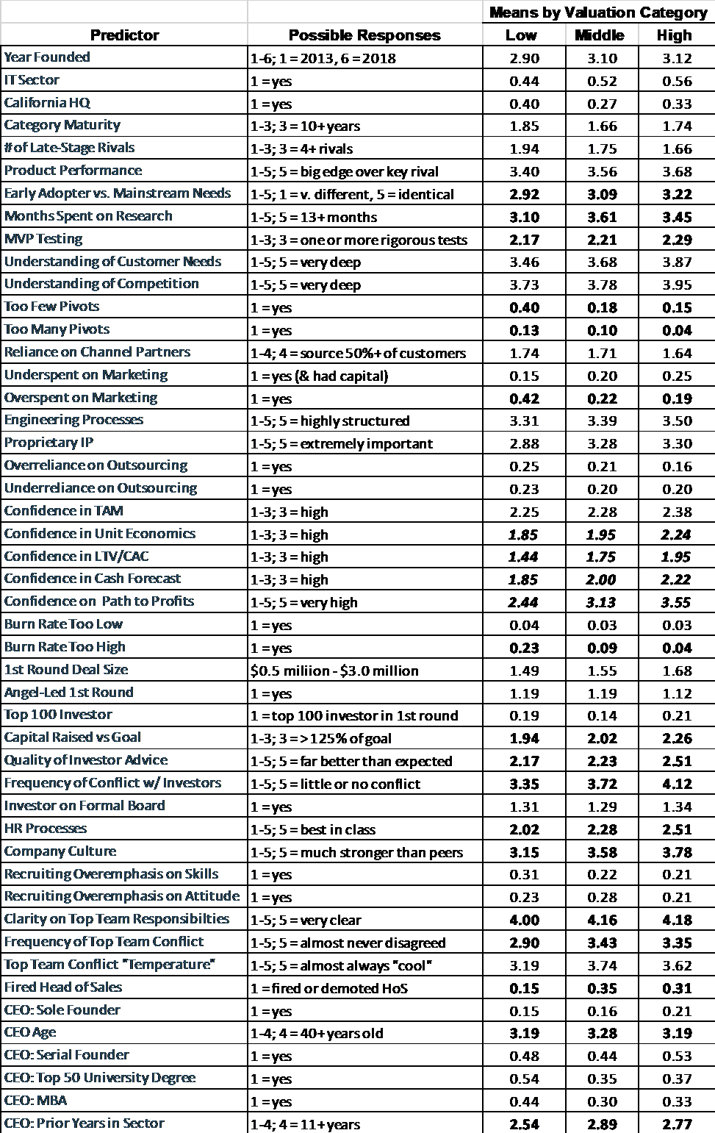

Bolded values are significant at p < .05 based on chi square test of bivariate relationship; italicized values are significant at p < .01.

## Table 2: Multinomial Regression Model

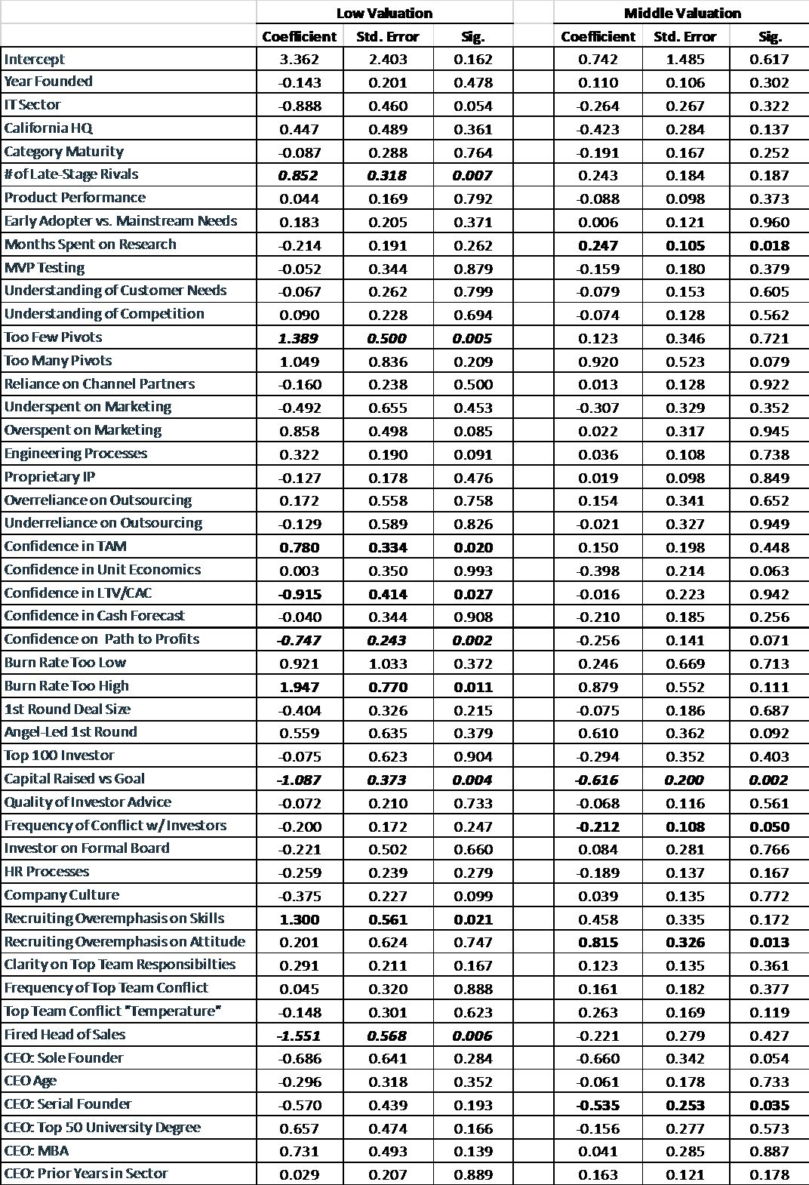

Reference category is high valuation.

Bolded values are significant at p < .05; italicized values are significant at p < .01.

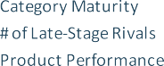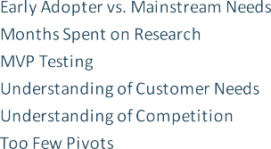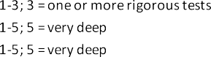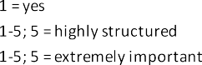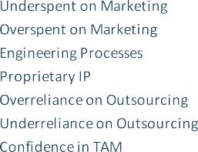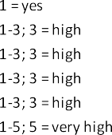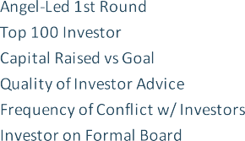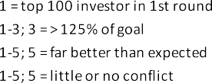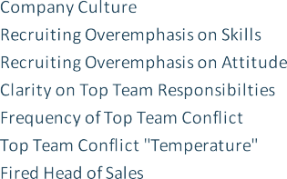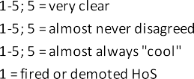Table 3: Predicted Probability of Low Valuation Ranging Predictors from Their Lowest to Highest Possible Value (with All Other Variables Held Constant at Their Sample Mean)

|  |  |  |  |  |
| --- | --- | --- | --- | --- |
|  |  |  | |  |
|  |  |  |  |
|  |  |  |  |  |
|  |  |  |  |  |
|  |  |  |  |  |
|  |  |  |  |  |
|  |  |  |  |  |
|  |  |  |  |  |
|  |  |  |  |  |
|  |  |  |  |  |
|  |  |  |  |  |
|  |  |  |  |  |
|  |  |  |  |  |
|  |  |  |  |  |
|  |  |  |  |  |
|  |  |  |  |  |
|  |  |  |  |  |
|  |  |  |  |  |
|  |  |  |  |  |
|  |  |  |  |  |
|  |  |  |  |  |
|  |  |  |  |  |
|  |  |  |  |  |
|  |  |  |  |  |
|  |  |  |  |  |
|  |  |  |  |  |
|  |  |  |  |  |
|  |  |  |  |  |
|  |  |  |  |  |
|  |  |  |  |  |
|  |  |  |  |  |
|  |  |  |  |  |
|  |  |  |  |  |
|  |  |  |  |  |
|  |  |  |  |  |
|  |  |  |  |  |
|  |  |  |  |  |
|  |  |  |  |  |
|  |  |  |  |  |
|  |  |  |  |  |
|  |  |  |  |  |
|  |  |  |  |  |
|  |  |  |  |  |
|  |  |  |  |  |
|  |  |  |  |  |
|  |  |  |  |  |
|  |  |  |  |  |
|  |  |  |  |  |
|  |  |  |  |  |
|  |  |  |  |  |

Bolded values denote parameter estimates in the regression model that are significant at p < .05; italicized values are significant at p < .01.

## Table 4: Models Testing Only “Jockey” Factors

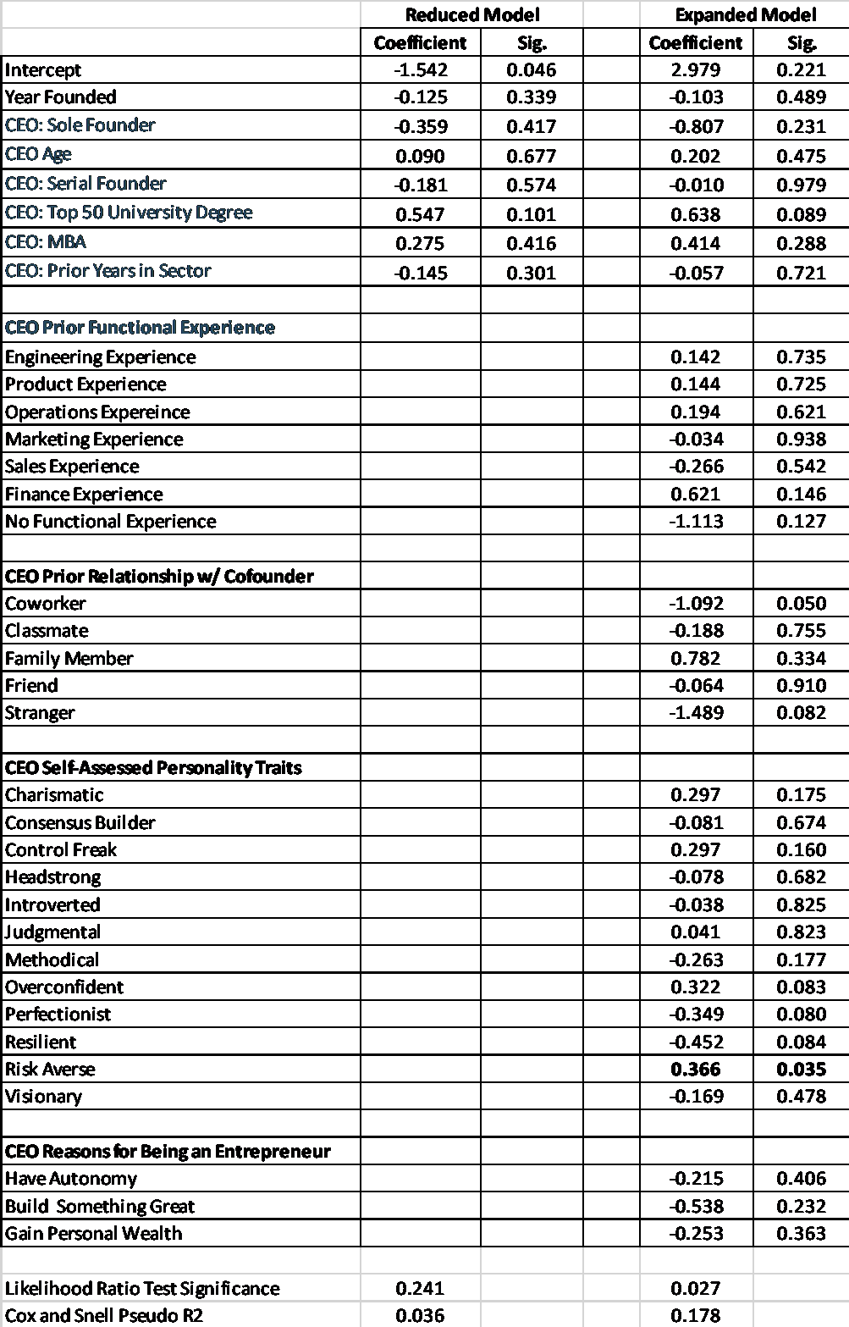

Reference category is high valuation.

Bolded values are significant at p < .05; italicized values are significant at p < .01.

## Table 5: Comparison of Opportunity and Resource Factors

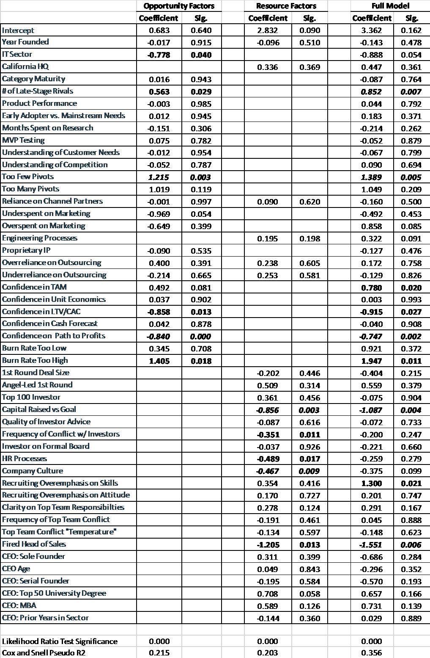

Reference category is high valuation.

Bolded values are significant at p < .05; italicized values are significant at p < .01.

# REFERENCES

Agarwal, R., Echambadi, R., Franco, A. and Sarkar, M.B. 2004. Knowledge transfer through inheritance: Spin-out generation, development, and survival. *Academy of Management Journal* 47 (4): 501-522.

Azoulay, P., Jones, B., Kim, J.D., and Miranda, J. 2020. Age and high-growth entrepreneurship.

*American Economic Review: Insights* 2 (1): 65-82.

Baron, R., and Markman, G. 2003. Beyond social capital: The role of entrepreneurs’ social competence in their financial success. *Journal of Business Venturing* 18: 41-60.

Bernardo, A., and Welch, I. On the evolution of overconfidence and entrepreneurs. *Journal of Economics & Management Strategy* 10 (3): 301-330.

Blank, S. 2013. How the lean startup changes everything. *Harvard Business Review* May 2013.

Bocken, N., and Snihur, Y. 2020. Lean startup and the business model: Experimenting for novelty and impact. *Long Range Planning* 53 (4).

Camerer, C., and Lovallo, D. 1999. Overconfidence and excess entry: an experimental approach.

*American Economic Review* 89 (1): 306-318.

Chatterji, A. 2009. Spawned with a silver spoon? Entrepreneurial performance and innovation in the medical device industry. *Strategic Management Journal* 30 (2): 185-206.

Camuffo, A., Cordova, A., Gambardella, A., and Spina, C. 2019. A Scientific Approach to Entrepreneurial Decision Making: Evidence from a Randomized Control Trial. *Management Science* 66

(2): 503-1004

Contigiani, A., and Levinthal, D. 2019. Situating the construct of lean start-up: adjacent conversations and possible future directions. *Industrial and Corporate Change* 28 (3): 551-564.

Eesley, C., and Roberts, E. 2012. Are you experienced or are you talented? When does innate talent versus experience explain entrepreneurial performance? *Strategic Entrepreneurship Journal* 6: 207-219

Eggers, J.P., and Song, L. 2015. Dealing with failure: Serial entrepreneurs and the cost of changing industries between ventures. *Academy of Management Journal* 58 (6): 1785-1803.

Eisenmann, T. 2006. Internet companies’ growth strategies: Determinants of investment intensity and long-term performance. *Strategic Management Journal* 27: 1183-1204.

Ensley, M., Pearson, A., and Amason, A. 2002. Understanding the dynamics of new venture top management teams: Cohesion, conflict, and new venture performance. *Journal of Business Venturing* 17: 365-386.

Felin, T., Gambardella, A., Stern, S., and Zenger, T. 2020. Lean startup and the business model: Experimentation revisited. *Long Range Planning* 53 (4).

Gorman, M., and Sahlman, W. 1989. What do venture capitalists do? *Journal of Business Venturing* 4 (4): 231-248.

Gompers, P., Gornall, W., Kaplan, S., and Strebulaev, I. 2020. How do venture capital investors make decisions? *Journal of Financial Economics* 135 (1): 169-190.

Gompers, P., Kovner, A., Lerner, J., and Scharfstein, D. 2010. Performance persistence in entrepreneurship. *Journal of Financial Economics* 96 (1): 18-32.

Greenberg, J., and Mollick, E. 2018. Sole survivors: Solo ventures versus founding teams. Working paper available on SSRN.

Hayward, M., Shepherd, D., and Griffin, D. 2006. A hubris theory of entrepreneurship. *Management Science* 52 (2): 160-172.

Hellmann, T., and Puri, M. 2000. The interaction between product market and financing strategy: The role of venture capital. *Review of Financial Studies* 13: 959-984.

Hogarth, R., and Karelaia, N. 2012. Entrepreneurial success and failure: Confidence and fallible judgment, *Organization Science* 23 (6): 1733-1747.

Kaplan, S., Sensoy, B., and Stromberg, P. 2009. “Should investors bet on the jockey or the horse? Evidence from the evolution of firms from early business plans to public companies,” *Journal of Finance* 64 (1): 75– 115.

Keogh D., and Johnson, D. 2019. Survival of the funded? An econometric analysis of new-firm survival and success. Colorado College Working Paper 2019-01.

Kerr, W., Nanda, R., and Rhodes-Kropf, M. 2014. Entrepreneurship as experimentation. *Journal of Economic Perspectives* 28 (3): 25-48.

Klepper S. 1997. Entry, exit, growth and innovation over the product life cycle. *American Economic Review* 86: 562–583.

Klotz, A., Hmieleski, K., Bradley, B., and Busenitz, L. 2014. New venture teams: A review of the literature and roadmap for future research. *Journal of Management* 40 (1): 226-255.

Macmillan, I., Zemann, L., and Subbanarasimha, P.N. 1987. Criteria distinguishing successful from unsuccessful ventures in the venture screening process. *Journal of Business Venturing* 2 (2): 123-137.

Noe, T., and Parker, G. 2005. Winner take all: Competition, strategy, and the structure of returns in the Internet economy. *Journal of Economics and Management Strategy* 14 (1): 141-164.

Ries, E. 2011. *The Lean Startup: How Today’s Entrepreneurs Use Continuous Innovation to Create Radically Successful Businesses.* Crown: New York.

Suarez, F., Grodal, S., and Gotsopoulos, A. 2015. Perfect timing? Dominant category, dominant design, and the window of opportunity for firm entry. *Strategic Management Journal* 36 (3): 437-448.

Schilling, M. 2017. Technology success and failure in winner-take-all markets: The impact of learning orientation, timing, and network externalities. *Academy of Management Journal* 45 (2).

Song, M., Podoynitsyna, K., van der Bij, H., and Halman, J. 2008. Success factors in new ventures: A meta-analysis. *Journal of Product Innovation Management* 25: 7-27.

Vanacker, T., Collewaert, V., and Paeleman, I. The relationship between slack resources and the performance of entrepreneurial firms: The role of venture capital and angel investors. *Journal of Management Studies* 50 (6): 1070-1096.

Wasserman, N. 2017. The throne vs. the kingdom: Founder control and value creation in startups.

*Strategic Management Journal* 38 (2): 255-277.

Zhao, H., Seibert, S. and Lumpkin, G.T. 2010. The relationship of personality to entrepreneurial intentions and performance: A meta-analytical review. *Journal of Management* 36 (2): 381-404.

#### APPENDIX: SURVEY QUESTIONNAIRE

Italicized terms in bold red text are defined in the glossary at the end of the survey.

OUTCOMES

**Q1: Please provide the current status of your venture and, if applicable, provide the approximate date when, as CEO, you committed to either an acquisition or shut down—not the date when this outcome was completed.** Select *“Acquired”* for an "acqui-hire," i.e., if another company acquired your venture’s equity and assets and retained some or all of your employees — even if that buyer subsequently shut down your operations. Select *"Shut Down"* if you ceased operations, terminated all employees, then perhaps sold off some assets.

* **We Are Still Operating and Independent**
* **We Committed To Be Acquired On (mm/yyyy)**
* **We Committed To Shut Down On (mm/yyyy)**

Q2: As of year-end 2019, before news of the pandemic was widespread, how much would someone have paid for your startup's 1st round equity/convertible notes?

We know that 1st round equity and convertible notes cannot normally be sold, but imagine that they could. How much might an experienced, well-diversified investor have paid your largest 1st round investor to take over their position on December 31, 2019? Assume that equity or notes would be transferred with terms intact (e.g., liquidation preferences; discounts and caps).

* **< 50% of the Amount Originally Invested**
* **Between 50% and 150% of the Amount Originally Invested**
* **150% of the Amount Originally Invested**

Q3: Which of the following best describes your cash flow and your fundraising plans as of year-end 2019, before news of the pandemic was widespread?

* **Our Cash Flow Was Negative, and We Were in the Midst of Fundraising or Planned to Raise Funds During 2020**
* **Our Cash Flow Was Negative, but We Had Enough Cash on Hand and DID NOT Plan to Raise Funds During 2020**
* **Our Cash Flow Was Positive, and We Were in the Midst of Fundraising or Planned to Raise Funds During 2020**
* **Our Cash Flow Was Positive, and We DID NOT Plan to Raise Funds During 202**

Q4: After shutting down, how did any proceeds distributed to 1st round investors compare to the amount they invested?

* **< 50% of the Amount Originally Invested**
* **Between 50% and 150% of the Amount Originally Invested**
* **150% of the Amount Originally Invested**

Q5: How did the value of acquisition proceeds distributed to 1st round investors compare to the amount they invested?

* **< 50% of the Amount Originally Invested**
* **Between 50% and 150% of the Amount Originally Invested**
* **> 150% of the Amount Originally Invested**

CONCEPT RESEARCH

Q6: Roughly how many full-time person months did your team spend on *concept research\** before you launched your product?

Count effort by each team member separately; convert part-time effort into full-time person months (e.g., three co-founders each working half-time for 3 months = 4.5 full-time person months); and include work done by contractors.

* **0: We Put All Our Effort Into Building Our Launch Product And Other Tasks**
* **1-2 Full-Time Person Months**
* **3-5 Full-Time Person Months**
* **6-12 Full-Time Person Months**
* **13+ Full-Time Person Months**

Q7: Before you launched your product, did you conduct rigorous minimum viable product *(MVP)\** tests? A *rigorous* test: 1) proves hypotheses true or false; 2) recruits typical target customers; and 3) considers the risk of false positive or false negative results.

* **We Did Not Conduct any MVP Tests**
* **We Conducted One or More MVP Tests, But They Weren't Very Rigorous**
* **We Conducted One or More Rigorous MVP Tests**

Q8: How deep was your team’s collective understanding of unmet customer needs before you launched your product?

* **Superficial**
* **Insufficient**
* **Moderate**
* **Deep**
* **Very Deep**

PRODUCT STRATEGY

Q9: During the first two years after you closed your 1st major round, how would you characterize your propensity to

*pivot\** in response to market feedback?

* **Far Too Few Pivots**
* **Too Few Pivots**
* **About Right**
* **Too Many Pivots**
* **Far Too Many Pivots**

Q10: How similar were the needs of your early adopters to those of “mainstream” customers? Assume that early adopters are acquired within the 1st six months after your product launch and mainstream customers are acquired one year or more after launch.

* **Very Different**
* **Different**
* **Some Differences, But NOT Significant**
* **Similar**
* **Nearly Identical**

Q11: What was your initial product strategy for dealing with any expected differences in the needs of early adopters and "mainstream" customers?

* **We Weren't Aware of the Different Needs of Early Adopters and Mainstream Customers When Designing Our Launch Product**
* **Our Launch Product Was Tailored for Early Adopters and We Never Planned to Modify It Significantly to Meet Mainstream Needs**
* **Our Launch Product Was Tailored for Early Adopters, but Over Time We Planned to Modify It Significantly to Meet Mainstream Needs**
* **Our Launch Product Was Tailored for Mainstream Customers, NOT for Early Adopters**

CUSTOMER VALUE PROPOSITION

**Q12: When you launched your product, how mature was your *product category\**?**

* **It Was Less Than 2 Years Old**
* **It Existed for 2 to 9 Years**
* **It Existed for 10 Years or More**

Q13: When you launched your product, how well did you understand competitors in your product category—their strategies, strengths and weaknesses, etc.?

* **Very Poorl y**
* **Poorl y**
* **Somewhat**
* **Fairly Well**
* **Very Well**

**Q14: When you launched your product, how many *direct competitors\** did you face?**

**Early Stage Startups (0-4 years old)**

**Later Stage Startups (5-10 years old)**

**Established Big Companies (11+ years old)**

**Small Businesses of Any Age (e.g., "Mom & Pops")**

**0 1-3 4+**

**□ □ □**

**□ □ □**

**□ □ □**

**□ □ □**

**Q15: One year after you launched your product, how did it compare to your most important competitor’s product in terms of offering unique features and performance benefits (e.g., speed, reliability, ease of use) strongly valued by customer segments your startup targeted?**

* **Our Rival Had Big Advantages**
* **Our Rival Had Modest Advantages**
* **We Were at Rough Parity**
* **We Had Modest Advantages**
* **We Had Big Advantages**

Q16: In hindsight, how would you assess the breadth of customer segments you were targeting one year after you launched your product?

* **We Targeted Far Too Few Segments**
* **We Targeted Too Few Segments**
* **Our Breadth of Segments Was About Right**
* **We Targeted Too Many Segments**
* **We Targeted Far Too Many Segments**

MARKETING SALES

**Q17: One year after you launched your product, how deep was your understanding of your *conversion funnel/conversion rates\**, *customer lifetime value\** and *customer acquisition costs\** for sales/marketing methods you employed?**

* **Little or No Understanding**
* **Some Understanding**
* **A Moderate Level of Understanding**
* **A High Level of Understanding**
* **A Very High Level of Understanding**

Q18: During the first year after you launched your product, what percentage of your customers were acquired through channel partners (e.g., value-added resellers; brick-and-mortar retailers; platforms like Amazon, Apple’s App Store, Salesforce)?

* **0%**
* **1-24%**
* **25-49%**
* **50-100%**

Q19: During the first year after you launched your product, how satisfied were you with your channel partners’ performance in helping you acquire and serve customers?

* **Extremely Dissatisfied**
* **Somewhat Dissatisfied**
* **Satisfaction and Dissatisfaction Roughly Balanced**
* **Somewhat Satisfied**
* **Extremely Satisfied**

Q20: How would you assess your overall level of spending to generate customer demand during your first year after launch, given the capital at your disposal?

* **We Overspent Significantly**
* **We Overspent Modestly**
* **Our Spending Was Optimal**
* **We Underspent, But We Had Ample Access to Capital**
* **We Underspent Because We Lacked Access to Capital**

PRODUCT/ENGINEERING/OPERATIONS

Q21: During the first two years after raising your 1st major round, how well did your engineering teams—either in-house or outsourced—perform, on average, in terms of meeting key deadlines?

Define *missing* a deadline as requiring more than 120% of the original budgeted time; and *beating* a deadline as requiring less than 80%.

* **Missed *Far* More Deadlines Than We Beat**
* **Missed More Deadlines Than We Beat**
* **Missed and Beat Deadlines At About The Same Frequency**
* **Beat More Deadlines Than We Missed**
* **Beat *Far* More Deadlines Than We Missed**

Q22: Two years after raising your 1st major round, to what extent was your engineering team employing structured product development tools and processes (sprints; daily standups; automated testing; continuous deployment; feature roadmaps; etc.)?

* **We Had Almost No Structure**
* **We Had Little Structure**
* **We Had Some Structure**
* **We Had Considerable Structure**
* **We Were Highly**

**Structured**

* **(X) Not Applicable: 100% of Product Development was Outsourced**

Q23: How important was proprietary intellectual property—either developed by your team or licensed from a 3rd-party—to your product’s performance?

* **Not At All Important**
* **Slightly Important**
* **Moderately Important**
* **Very Important**
* **Extremely Important**

Q24: When confronting “make/buy” decisions for technology and/or operational capacity, should you have relied on third-party suppliers less or more?

Technology decisions might involve developing software in-house vs. outsourcing to contractors or licensing from vendors. Operational capacity decisions might involve warehouses, call centers, etc.

* **Much Less**
* **Somewhat Less**
* **Our Level of Reliance Was About Right**
* **Somewhat More**
* **Much More**

FINANCIAL AND ECONOMIC ANALYSIS

Q25: Two years after raising your 1st major round, how confident were you in your projections for the following financial metrics?

**Low Confidence**

**Moderate Confidence**

**High Confidence**

**Size of Your Product's *Total Addressable Market\****

**□ □ □**

***Unit Economics\** □ □ □**

***LTV/CAC Ratio\** □ □ □**

**Cash Flow Projections for the Next Six Months**

**□ □ □**

**Q26: Two years after raising your 1st major round, what was your level of confidence that you had *a clear path to a long-term profitability\**?**

* **Very Low**
* **Low**
* **Moderate**
* **High**
* **Very High**

Q27: In hindsight, given the opportunity you were pursuing, your economic model, competitive dynamics, your ability to raise more capital, etc., how would you assess your burn rate during the first two years after raising your 1st major round?

* **Much Too Low**
* **Lower than Optimal**
* **Close to Optimal**
* **Higher than Optimal**
* **Much Too High**

INVESTORS

Q28: Compared to your goal when you started to raise your 1st major round, how much capital did you actually raise?

If you raised capital over time through a “rolling” seed round, consider the total amount raised. If you subsequently raised a second, separate round (e.g., a seed "extension") do not include it as part of your 1st major round.

* **< 75%**
* **75 - 125%**
* **> 125%**

Q29: Compared to your expectations when you closed your 1st major round, how much value (via introductions, advice, etc.) did the largest investors in that round provide, beyond capital?

* **Much Less Than Expected**
* **Somewhat Less Than Expected**
* **About What Was Expected**
* **More Than Expected**
* **Far More Than Expected**

Q30: To what extent did you experience conflict with investors over key decisions about strategy, fundraising, exit options, etc.?

* **We Frequently Experienced Serious Divisive Conflict**
* **We Experienced Some Conflict -- Both Constructive and Divisive**
* **We Experienced A Moderate Amount Of Conflict**
* **We Experienced Some Conflict, But It Was Mostly Constructive**
* **We Experienced Little Or No Conflict**

Q31: Within a few months after raising your 1st major round, did you have a formal board of directors that included at least one investor from that round?

* **Yes**
* **No**

TEAM

Q32: Rate the know-how and leadership ability of each function's head two years after you raised your 1st major round, relative to requirements for success in their function at that time.

Your response should reflect the lowest level manager to whom all employees in the function reported, at the time. For example, if your startup had a CTO with two direct reports: VP-Engineering and VP-Product, to whom all engineers and product managers respectively reported, your responses should be based on the VPs, not the CTO.

**Below Requirements**

**Met Requirements**

**Exceeded Requirements**

**(X) Did NOT Have This Function**

**Engineering □ □ □ □**

**Product Management □ □ □ □**

**Operations (Including Customer Service)**

**□ □ □ □**

**Marketing □ □ □ □**

**Sales □ □ □ □**

**Finance □ □ □ □**

Q33: During the first two years after you raised your 1st major round, did you have to replace the head of any function, either because they resigned voluntarily, or you fired/demoted them due to poor performance? (Check ALL that apply)

**Replaced Due to Voluntary Resignation**

**Fired/Demoted Due To Poor Performance**

**Did Not Replace**

**(X) Did NOT Have This Function**

**Engineering □ □ □ □**

**Product Management □ □ □ □**

**Operations (Including Customer Service)**

**□ □ □ □**

**Marketing □ □ □ □**

**Sales □ □ □ □**

**Finance □ □ □ □**

Q34: Two years after you raised your 1st major round, to what extent did you have well-structured human resources policies and processes for recruiting, on- boarding new employees, training, performance reviews, compensation, etc.?

* **We Had Almost No HR Structure**
* **We Had A Little HR Structure**
* **We Had a Moderate Level of Structure**
* **We Had a Lot of HR Structure**
* **We Had Best-in-Class HR Structure**

**Q35: In retrospect, considering the first 30 employees you hired, how well did you strike a balance between**

***hiring for skill and hiring for attitude*?***

If you hired fewer than 30 employees, bas e your response on those you did hire.

* **We Put *Way* Too Much Emphasis On Skill**
* **We Put Too Much Emphasis On Skill**
* **About Right**
* **We Put Too Much Emphasis On Attitude**
* **We Put *Way* Too Much Emphasis On Attitude**

Q36: Two years after you raised your 1st major round, how strong was your *company culture\**, compared to that of other similar startups (e.g., those of roughly the same age and in your industry sector)?

* **Much Weaker**
* **Weaker**
* **On Par**
* **Stronger**
* **Much Stronger**

FOUNDERS

Q37: What best describes your role in your startup when you raised your 1st major round?

* **I was CEO and one of two or more co- founders**
* **I was CEO and the sole founder**
* **I was CEO but not a co-founder**

Q38: What was your relationship with each co-founder prior to launching this venture? (Check all that apply) If more than three co-founders joined you on the top management team, respond regarding the three you feel had the biggest impact on your startup's performance. If fewer than three joined you, check "(X) Did Not Have Specified Co-founder," in the appropriate row for this question and those that follow.

**Current or Former Coworker**

**Current or Former Classmate**

**Family Member**

**Casual Acquaintance or Stranger**

**(X) Did Not Have Specified**

**Co-founder**

**1st Co- founder □ □ □ □ □ 2nd Co- founder □ □ □ □ □ 3rd Co- founder □ □ □ □ □**

Q39: Prior to launching this venture, how many years of full-time work experience did you and any co- founders have in the industry sector in which your venture operated?

Businesses are in the same "sector" if they serve similar types of customers and/or operate in similar ways. For example, direct-to-consumer, SaaS, and real estate brokerage are sectors. For our purposes, "business-to business" is too broad to be called a sector; "online wedding registry" is too narrow.

**0 Years 1-3 Years 4-10 Years 11+ Years**

**(X) Did Not Have Specified**

**Co- founder**

**You □ □ □ □ □ 1st Co- founder □ □ □ □ □ 2nd Co- founder □ □ □ □ □ 3rd Co- founder □ □ □ □ □**

Q40: Prior to launching this venture, did you or any co-founders have at least two years of full-time work experience in any of the following functions? (Check all that apply)

**Eng. Product Ops. Mkting. Sales Fin.**

**Did not have experience in any function**

**(X) Did Not Have Specified**

**Co- founder**

**You □ □ □ □ □ □ □ □**

**1st Co- founder 2nd Co- founder**

**3rd Co- founder**

**□ □ □ □ □ □ □ □**

**□ □ □ □ □ □ □ □**

**□ □ □ □ □ □ □ □**

Q41: One year after you raised your 1st major round, how clear was the division of responsibilities between members of your top management team (i.e., founders, other "C"-level executives, or the equivalent)?

* **Not Clear At All**
* **Not Very Clear**
* **Not Always Clear, But Not Too Confusing**
* **Somewhat Clear**
* **Very Clear**

Q42: In the two years after raising your 1st major round, how much conflict—either *"cool"\** or *"hot"\** — was there between members of your top management team over key decisions about strategy, product design, hiring, fundraising, etc.?

* **We Experienced Conflict Almost Daily**
* **We Experienced Conflict Frequently**
* **We Experienced A Moderate Amount Of Conflict**
* **We Experienced Little Conflict**
* **We Almost Never Disagreed**

Q43: On a spectrum from *"hot"\** to *"cool"*,* how would you characterize disagreements among members of your top management team?

* **Almost Always Hot**
* **Usually Hot**
* **Cool and Hot Episodes were in Rough Balance**
* **Usually Cool**
* **Almost Always Cool**

Q44: How old were you when you raised your startup's 1st major investment round?

* **18-24 Years Old**
* **25-29 Years Old**
* **30-39 Years Old**
* **40+ Years Old**

Q45: What best describes your gender?

* **Male**
* **Female**
* **Transgender, Non-Binary, Non-Conforming, Other Prefer to Not Disclose**

Q46: In the context of leading your venture, how well would your team members and investors say that the following terms describe you?

**Does not usually describe me**

**Describes me moderately**

**Describes me well**

**Describes me very well**

**Control Freak □ □ □ □ Headstrong □ □ □ □ Overconfident □ □ □ □ Visionary □ □ □ □ Consensus Builder □ □ □ □ Methodical □ □ □ □**

**Charismatic □ □ □ □**

**Resilient □ □ □ □ Perfectionist □ □ □ □ Introverted □ □ □ □**

**Judgmental □ □ □ □**

**Risk Averse □ □ □ □**

Q47: To what extent did the following motivate your decision to pursue an entrepreneurial career?

**Not At All A Motivation**

**A Meaningful Consideration**

**A Crucial Concern**

**Desire For Autonomy (i.e., be My Own Boss)**

**Desire For Control (i.e., Have Power To Set Strategy And Ensure Implementation)**

**Desire To Build Something New**

**/ Enduring / Important**

**□ □ □**

**□ □ □**

**□ □ □**

**Desire To Accumulate Wealth □ □ □**

OPTIONAL: If you could wind back the clock and do it all over again, what's the single most important thing you'd do differently in managing and leading your startup?

GLOSSARY

***A clear path to a long-term profitability***

A clear path to long-term profitability implies you had demonstrated demand; a proven monetization model; a repeatable, scalable and cost-effective approach for acquiring customers; and could raise enough capital to fund expected growth.

***Company culture***

In a startup with a strong culture, employees ‘just know’—without being told—how they should interact with each other and/or outsiders in any given situation, by virtue of shared values, beliefs and behavioral norms.

***Concept research***

Concept research explores customer needs and solutions for them. It includes customer interviews; market sizing; competitor analysis; getting feedback on prototypes; MVP testing; etc. Include work on prototypes used to explore solutions that were subsequently discarded, but not work on your actual launch product.

***Conversion funnel***

A company’s conversion funnel tracks stages in a potential buyer’s journey from initial interest to repurchase, with the funnel’s shape reflecting conversion rates, as some prospects progress to the next stage but others do not.

***Cool***

“Cool” implies lots of logical reasoning, listening carefully to understand the other side’s views, graceful acceptance by the losing side, etc.

***Customer Lifetime Value***

Customer lifetime value (LTV) reflects the discounted present value of profit contribution (revenue less variable costs, excluding marketing expenses) earned over the life of a typical customer relationship.

***Customer Acquisition Costs***

Customer acquisition cost (CAC) reflects the marketing expense incurred to attract a new customer.

***Direct competitors***

A product is your direct competitor if a large fraction of first-time buyers in your category would seriously consider it alongside yours.

***Hiring for skill and hiring for attitude***

Employees hired principally for *attitude* are generalist “jack-of-all-trades” who’ll pitch in and eagerly help with any task. Those hired for *skill* have specific functional expertise required by the startup, e.g., performance marketing know-how; deep experience with user interface design.

***Hot***

“Hot” implies emotional appeals, threats, stonewalling, sore losers, etc.

***LTV/CAC ratio***

Customer lifetime value (LTV) reflects the discounted present value of profit contribution (revenue less variable costs, excluding marketing expenses) earned over the life of a typical customer relationship. Customer acquisition cost (CAC) reflects the marketing expense incurred to attract a new customer.

***MVP test***

With as little wasted effort as possible, an MVP tests assumptions about customers’ problems, potential solutions, or a venture’s business model. Examples include: 1) landing page tests, letters of intent, and crowdfunding campaigns that gauge demand before a product is built; 2) early product versions that include core features but omit secondary features; and 3) “concierge” tests that substitute manual effort for “back-end” activities that eventually will be automated.

***Pivot***

A pivot makes a significant change to one or more of the following business model elements, typically in response to customer feedback, while retaining other elements: 1) target customer segments; 2) product features; 3) marketing approach; and/or 4) monetization approach.

***Product category***

Customers use a generic term to describe products they perceive to be in the same category, e.g., smartphones, online dating. With new categories, customers may not yet agree on the term.

***Total Addressable Market***

TAM is the total opportunity for products like yours in a specified geographic territory; it assumes you have 100% market share.

***Unit economics***

Unit economics reflect profit contribution per transaction or per customer, typically calculated as revenue minus variable operating costs, excluding customer acquisition costs and allocations of fixed expenses.